Project title (Space Invaders)
Author (Bejan Martha)
affiliation: <Faculty of Automatic Control and Computer Engineering, Iasi>,
email: <b17.martha@gmail.com>,
academic year: <2018 - 2019>
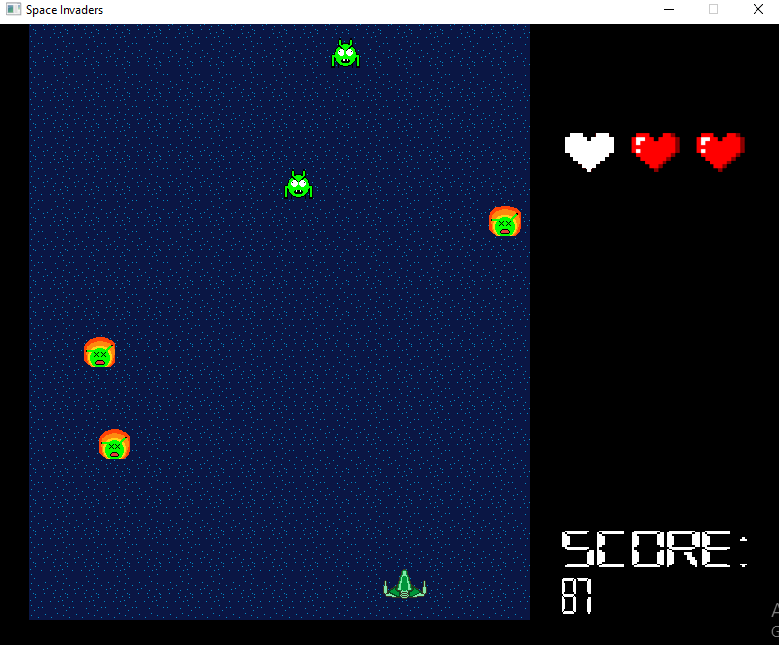

- Gameplay: Space invaders is a fixed shooter. The player controls a space ship by moving it horizontally across the bottom of the screen, firing at aliens. If the player defeats an alien by shooting him, the score increases. The object is to defeat as many aliens as possible and protect the Earth. The aliens catch fire when they enter Earth’s atmosphere and become a real danger. The game ends when the player is defeated and is hit by aliens more than 4 times.
- Plot: Sometime in the near future, Earth is invaded by aliens from another galaxy. And humanity’s fate is in the hands of one brave spaceship pilot.
- Characters:
    - The aliens: Evil creatures from across the space, the green aliens come to invade and conquer the Earth. Unfortunately for them, their form does not allow them to pass Earth’s atmosphere and they catch fire, but they still pose a real danger to humanity as their flaming bodies poison the atmosphere.
- Mechanics: Use the LEFT/RIGHT arrow keys to move the spaceship horizontally across the bottom of the screen and SPACE key to shoot the aliens.

